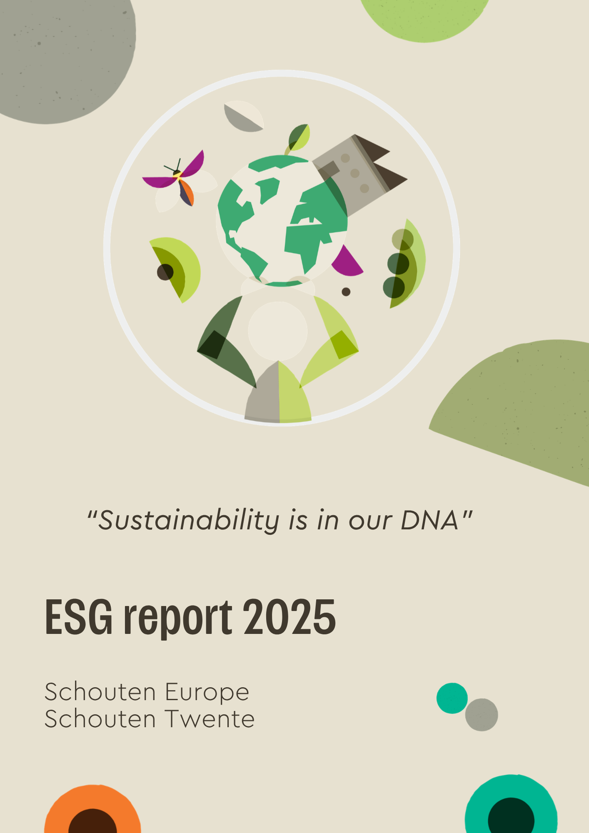

Contents
Foreword 3
About this report 4
General basis for preparing this sustainability statement 5
Industry information 7
About Schouten 8
Who we are, what we do and what drives us 8
Management 9
Value chain 10
Stakeholder prioritisation 12
Double materiality analysis 12
ESRS framework for possible material topics 12
DMA matrix 13
Protein transition 15
Climate 16
Climate and energy 16
Greenhouse Gas Protocol 19
SBTi commitment 19
Pollution, biodiversity and water 20
Circularity 23
Social 25
Responsible employment practices 25
Housing for migrant workers 27
Social conditions in the value chain 28
Consumers 29
Governance 30
Business conduct 30
Appendix 1 Stakeholder mapping 33
Appendix 2: Double Materiality Analysis 36
Appendix 3: Example Impact Score Schouten Vegan Filet 37
Appendix 4: Explanation of SBTi commitment and Scope 1 and 2 emissions development 38

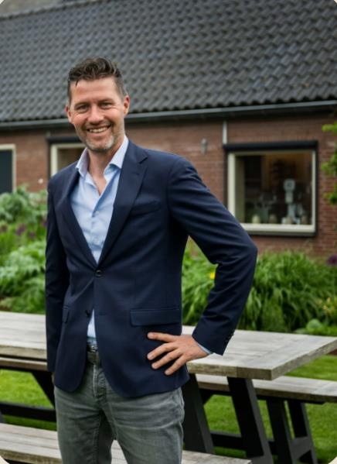
Foreword
For more than 35 years, we have been developing plant-based products. This places Schouten at the heart of the protein transition. This ESG report marks the next step in the continued professionalization of our sustainability approach.
As an SME, we make deliberate choices in our priorities, in line with our size and position in the value chain. In the reporting year, Schouten Europe and Schouten Twente completed a double materiality analysis. The outcomes form the basis for this first ESG report and guides the topics that are relevant to our organization, customers and other stakeholders.
The discussions with customers, partners and colleagues have provided greater insight into expectations, risks, opportunities and areas for improvement. I value the involvement of everyone who contributed. Sustainability requires clear choices, reliable data and consistent follow-up within the organization.
This report shows where we currently stand. We distinguish between elements that have already been implemented and elements that require further development. This creates a basis for further management, improvement and transparency.
Together, we continue to build plant-based solutions that add value for customers, value chain partners, people and the planet.
Niek-Jan Schouten
CEO

About this report
The Corporate Sustainability Reporting Directive (CSRD) was adopted by the European Parliament in 2022. As part of Schouten Family Companies (SFC), Schouten Europe and Schouten Twente fell within the second reporting group, with the first CSRD report expected for financial year 2025. In 2025, the so-called stop-the-clock mechanism was adopted, postponing the application of the CSRD for undertakings in this reporting group.
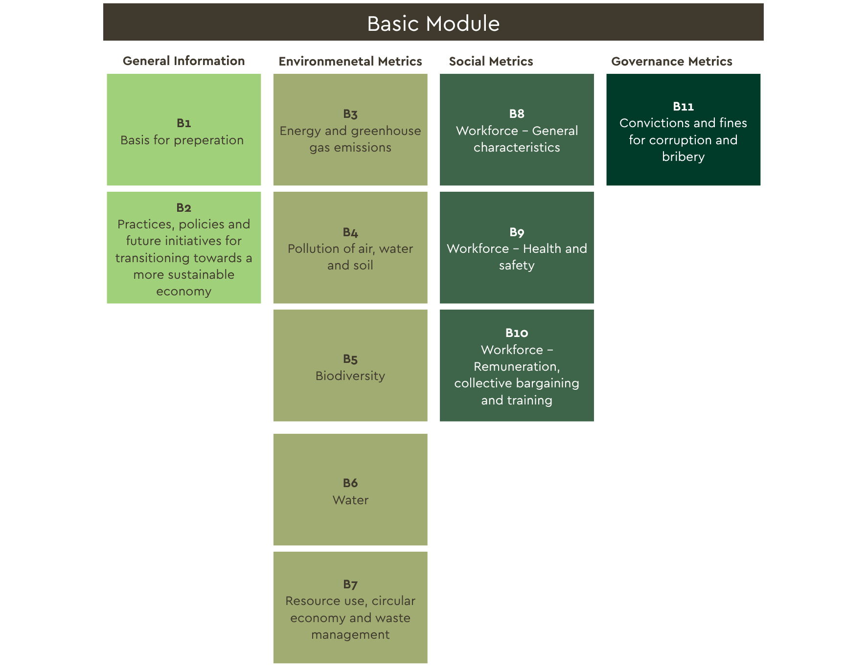
Despite this postponement, Schouten is receiving an increasing number of information requests from customers and value chain partners about ESG topics. Schouten has therefore opted for a voluntary ESG report for 2025, prepared on the basis of the VSME Basic Module (B1-B11) (see Figure 1).
Figure 1: Schouten reports according to the VSME Basic Module
In addition, Schouten, together with external partner Cooperate Green, carried out a double materiality analysis. The double materiality analysis was already at an advanced stage when it became clear that the CSRD reporting obligation would shift in the short term. Schouten chose to complete the analysis and use the outcomes as the basis for this report. The analysis maps the key impacts, risks and opportunities within the organization and in the value chain. The outcomes determine which topics are addressed in this report.
This first report provides a basis for further data collection, policy development and internal embedding. Schouten will develop its ESG reporting further in phases over the coming years, in line with the size of the organization, the available data and the information needs of customers and value chain partners. The primary function of this report is to inform current and potential partners and other interested parties. The report will be updated annually.

General basis for preparing this sustainability statement
This report describes Schouten's ESG topics for financial year 2025. The report has been prepared on the same combined basis as the financial annual report. In this report, Schouten refers to Schouten Europe B.V. and Schouten Twente B.V., unless explicitly stated otherwise. Assurance is not part of this report.
Schouten has an action-oriented and entrepreneurial way of working. Until now, the focus has mainly been on practical implementation. For ESG reporting, this requires further documentation of policies, processes, responsibilities and follow-up. With this report, Schouten is taking a first step towards greater structure, transparency, verifiability and internal embedding.

Scope of the report
This report covers the following entities within Schouten Family Companies:
- Schouten Europe B.V.
- Schouten Twente B.V.

